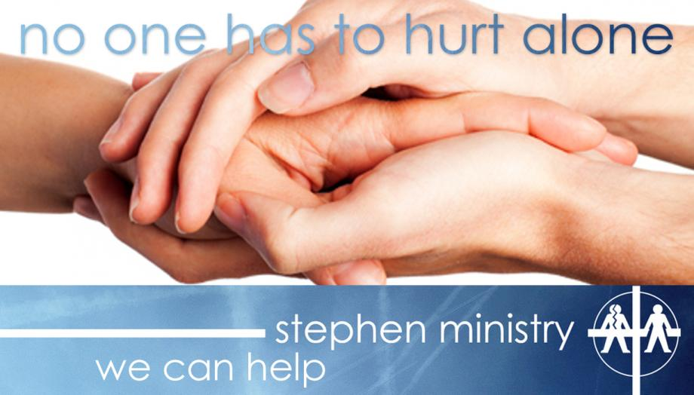
Confidential, nonjudgmental, one-on-one Christian care.
Shepherd of the Sea has 15 Stephen Ministers who have received over 50 hours of special training to provide high-quality, confidential, one-to-one, Christian care to hurting people. Stephen Ministers are lay care givers who meet weekly with their care receivers to listen, care, encourage, and provide emotional and spiritual support. (Males are matched with males, and females are matched with females.) The caring relationship lasts for as long as the person needs care.

Who might benefit from a Stephen Ministry relationship?
We all experience challenges in life when we could benefit from the support of a caring Christian friend who may have experienced similar difficulties. Situations in which a person might seek a Stephen Minister include:
• Loss of a loved one • A broken relationship, divorce, separation • Hospitalization • Employment crisis or unemployment • Spiritual crisis • Terminal or chronic illness • Traumatic accident or event • Homebound, loneliness, aging, nursing home • Relocating or facing life transitions • Birth/adoption, miscarriage, or infertility • Children leaving home, parents needing extra care • Incarceration of a loved one

Confidentiality in Stephen Ministry

Confidentiality is essential for building safe, healing, caring relationships. Stephen Ministers don’t reveal what their care receivers have told them…not to clergy, not to the Stephen Leaders, not to their spouses or friends and not to other Stephen Ministers. Why? Because trust is vital for a caring relationship to be effective. No one except the Stephen Minister, the care receiver, and the clergy or Stephen Leader even know that a care receiver has been assigned Stephen Minister. Care receivers, of course, are free to tell others about the relationship and who their Stephen Minister is, but the Stephen Minister never tells.

Peer Supervision
Our Stephen Ministers meet twice monthly for peer supervision and continuing education. During supervision the focus of discussion is on the relationship between the Stephen Minister and the care receiver, rather than the details of what is going on in the care receiver’s life. By not revealing a care receiver’s name or any significant details, confidentiality is maintained, and supervision becomes a place where Stephen Ministers can support and encourage one another in ministry while they provide the best quality care to their care receivers

How do I request a Stephen Minister either for myself or someone I know?

If you or someone you know would like to be matched with a Stephen Minister please contact Pastor Brad Bellah or our Stephen Ministry Leader Mandy Bellah at stephenministry@shepherdofthesea.com. They will be able to answer any questions you have about Stephen Ministry and begin the process of making a Stephen Ministry relationship match. All requests for Stephen Ministers are kept confidential.

Are you interested in becoming a Stephen Minister?
If you have gifts for caring, encouragement, and listening, please prayerfully consider becoming a Stephen Minister. This is a wonderful opportunity to grow in faith, develop stronger relationship skills, and bring Christ’s love into the lives of hurting people. We will have a new training class beginning in September 2017.

For more information about Stephen Ministry, or to be put in touch with a Stephen Minister, please contact Mandy Bellah- stephenministry@shepherdofthesea.com.

