BAPTISM
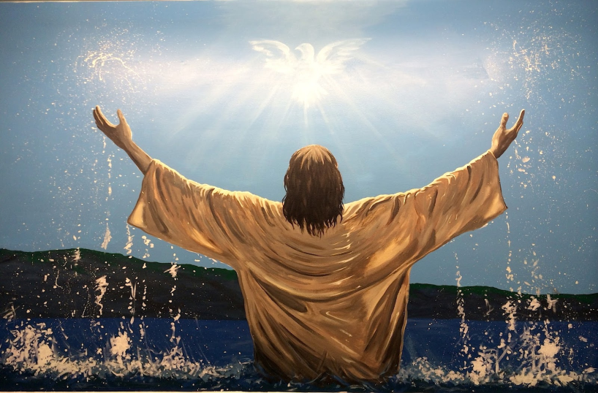

We are a church whose unity is in Jesus Christ, who gathers us around word and water, wine and bread. Baptism is a significant part of our faith journey as we come from the baptismal waters to live a new life as children of God.
Our baptism sets us out on a lifelong journey that is characterized by our relationship to God, our relationship to our faith community, our relationships in our community and the wider world. Living our baptismal covenant means living a life of growth in the faith practices of discipleship.
The liturgy for the Affirmation of Baptism describes the faith practices that grow out of our baptism (Evangelical Lutheran Worship, page 236). We are to “...live among God’s faithful people; hear the word of God and share in the Lord’s Supper; proclaim the good news of God in Christ through word and deed; serve all people following the example of Jesus; and strive for justice and peace in all the earth.”

To request that you or your child be baptized at Shepherd of the Sea, please complete the baptism information form and email it to shepcluth@gmail.com or call the church office at
843-651-7377

